**Freedom Songs**

Opening Song: *Ella’s Song: We Who Believe in Freedom Cannot Rest*

by Sweet Honey in the Rock (2008) <https://www.youtube.com/watch?v=U6Uus--gFrc>

We who believe in freedom cannot rest

We who believe in freedom cannot rest until it comes

Until the killing of black men, black mothers' sons

Is as important as the killing of white men, white mothers' sons

The older I get the better I know that the secret of my going on

Is when the reins are in the hands of the young, who dare to run against the storm

To me young people come first, they have the courage where we fail

And if I can but shed some light as they carry us through the gale

Struggling myself don't mean a whole lot, I've come to realize

That teaching others to stand up and fight is the only way my struggle survives

I'm a woman who speaks in a voice and I must be heard

At times I can be quite difficult, I'll bow to no man's word

Not needing to clutch for power, not needing the light just to shine on me

I need to be one in the number as we stand against tyranny

We who believe in freedom cannot rest

We who believe in freedom cannot rest until it comes.

Ella Baker played a key role in Civil Rights organizations including the NAACP, the Southern Christian Leadership Conference, and the Student Nonviolent Coordinating Committee. Bernice Johnson Reagon, the founder of Sweet Honey in the Rock, used Ella’s words to create the lyrics of this song. The song celebrates Ella’s life, and reminds us that working for justice has always been a long-term commitment.

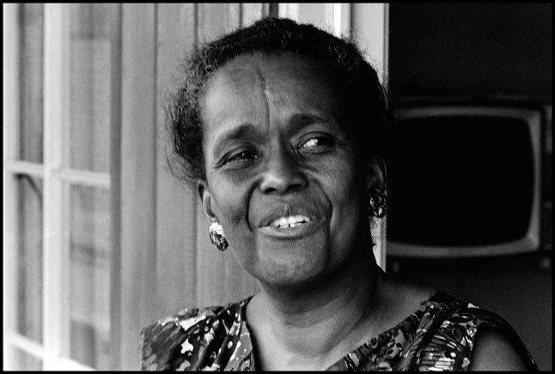‘What touches me most, is that I had a chance to work with people: passing on to others what had been passed on to me.’

Ella Baker (1903-1986)

Closing Song: *Something Inside So Strong*

by Labi Siffre (1984) <https://www.youtube.com/watch?v=EmNclh9lVkU>

1. The higher you build your barriers

The taller I become

The further you take my rights away

The faster I will run

You can deny me

You can decide to turn your face away

No matter, 'cause there's

r. Something inside so strong

I know that I can make it

Though you're doing me wrong,

so wrong

You thought that my pride was gone

Oh no, something inside so strong

Oh, something inside so strong

2. The more you refuse to hear my voice

The louder I will sing

You hide behind walls of Jericho

Your lies will come tumbling

Deny my place in time

You squander wealth that's mine

My light will shine so brightly

It will blind you, 'cause there's

r. Something inside so strong …

3. Brothers and sisters

When they insist we're just

not good enough

When we know better

Just look 'em in the eyes and say

"We're gonna do it anyway"

"We're gonna do it anyway!"

r. Something inside so strong …

Labi Siffre was born in Hammersmith in 1945. He is a poet, singer and songwriter. ‘Something Inside so Strong’ has become his most famous and widely played song. In 2014, Labi told the BBC's *Soul Music* programme that this song was inspired by two aspects of his life: a television documentary that he saw on apartheid in South Africa, which moved him very deeply; and his own experience as a gay person, both growing up and as an adult.

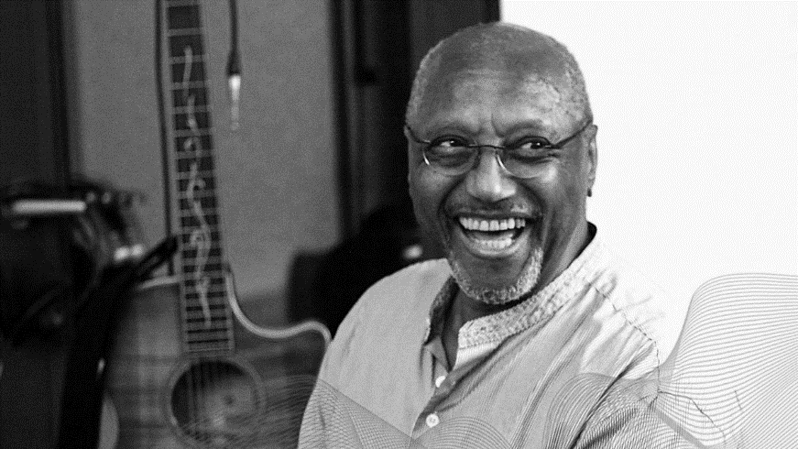

‘They rule the land

head in the sand.

With all the world

against us

one thing's for sure:

I just love you more’

* *Why Isn't Love Enough*

Labi Siffre